St William of York Catholic Primary School
Brockley Park, Forest Hill, London SE23 1PS



Teaching Assistant
Application Pack

Closing Date: 12th June 2026
Shortlisting Date: 12th June 2026
Interview Date: 16th June 2026

Teaching Assistant, St William of York Catholic Primary School
Brockley Park, Forest Hill, London, SE23 1PS www.swoy.lewisham.sch.uk

Job title: Teaching Assistant and Midday Meal Supervisor
Start date: 1st September 2026
Hours: 26.25 (Teaching Assistant) + 5 hours (Midday Meal Supervisor)
Contract type: Fixed Term Contract (12 months)
Pay: £30,552 (pro rata to term-time only) (Scale 3, Spine Point 6)

We would love you to join our committed and hardworking team. Our school is a great place to learn and work. We can offer a supportive and friendly team of staff, governors, parents, pupils and parishioners.

We are looking for someone to work with the class teacher, to ensure inclusion within the class setting and to support children with SEN. Experience of supporting young pupils with ASC and Speech and Language is essential.

You must be able to work as part of a team and have good communication skills. You must, of course, be committed to ensuring all children have a positive experience of learning, and understand your key role in making this a reality for our pupils. You must have a sense of humour and be willing ‘to go the extra mile’. As part of your role, you will be required to teach intervention groups, training will be given. Ideally, you will also understand how to teach early reading and phonics.

You must also have a minimum of 5 GCSE’s (A-C) including Maths and English, and preferably either A Levels or evidence of Higher education qualifications.

As well as working in the classroom, you will be required to work as a Midday Meals Supervisor, for which you will receive an additional payment. The successful candidate must be flexible and hardworking. In addition, a willingness to learn and a commitment to inclusion and equality is integral to the role.

The Governing Body of St William of York catholic Primary Schools has a primary responsibility for the care, welfare, safety and wellbeing of all our pupils and expects all our staff and volunteers to share this commitment. Applicants invited to interview stage will be required to complete a Self-Disclosure form in line with Keeping Children Safe in Education (KCSIE). Further vetting checks in line with the requirements of KCSIE, will be completed following a provisional offer of appointment.

Visits to the school are encouraged, please contact admin@swoy.lewisham.sch.uk to arrange a visit. Completed application forms should be emailed to the headteacher via recruitment@swoy.lewisham.sch.uk.

Closing Date: 12th June 2026
Interview Date: 16th June 2026

Location
We are located next to our parish church on Brockley Park, which is just off of the main road Brockley Rise. We are a 15-minute walk from Honor Oak Park station and an 18-minute walk from Forest Hill station and Catford station.

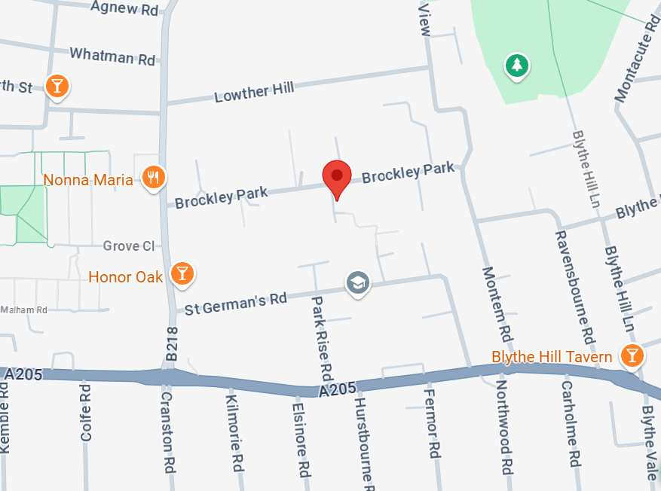

Job Description: Teaching Assistant



Main purpose
The TA will:
- Work with class teachers to raise the learning and attainment of pupils
- Promote pupils’ independence, self-esteem and social inclusion
- Give support to pupils, individually or in groups, so they can access the curriculum, take part in learning, and experience a sense of achievement

Duties and responsibilities
Teaching and learning
- Demonstrate an informed and efficient approach to teaching and learning by adopting relevant strategies to support the work of the teacher and increase achievement of all pupils including, where appropriate, those with special educational needs and disabilities (SEND)
- Promote, support and facilitate inclusion by encouraging participation of all pupils in learning and extracurricular activities
- Support the teaching of a broad and balanced curriculum aimed at pupils achieving their full potential in all areas of learning
- Use effective behaviour management strategies consistently in line with the school’s policy and procedures
- Support class teachers with maintaining good order and discipline among pupils, managing behaviour effectively to ensure a good and safe learning environment
- Organise and manage teaching space and resources to help maintain a stimulating and safe learning environment
- Observe pupil performance and pass observations on to the class teacher
- Supervise a class if the teacher is temporarily unavailable
- Use ICT skills to advance pupils’ learning
- Undertake any other relevant duties given by the class teacher
- Deliver interventions to small groups of pupils
Planning
- Contribute to effective assessment and planning by supporting the monitoring, recording and reporting of pupil performance and progress as appropriate to the level of the role
- Read and understand lesson plans shared prior to lessons, if available
- Prepare the classroom for lessons
Working with staff, parents/carers and relevant professionals
- Communicate effectively with other staff members and pupils, and with parents and carers under the direction of the class teacher
- Communicate their knowledge and understanding of pupils to other school staff and education, health and social care professionals, so that informed decision making can take place on intervention and provision
- Contribute to meetings with parents and carers by providing feedback on pupil progress, attainment and barriers to learning, as directed by teachers
- With the class teacher, keep other professionals accurately informed of performance and progress, or concerns they may have about the pupils they work with
- Understand their role in order to be able to work collaboratively with classroom teachers and other colleagues, including specialist advisory teachers
- Collaborate and work with colleagues and other relevant professionals within and beyond the school
- Develop effective professional relationships with colleagues
Health and safety
- Promote the safety and wellbeing of pupils, and help to safeguard pupils’ wellbeing by following the requirements of Keeping Children Safe in Education (KCSIE) and our school’s child protection policy
- Look after children who are upset or have had accidents
Professional development
- Help keep their own knowledge and understanding relevant and up-to-date by reflecting on their own practice, liaising with school leaders, and identifying relevant professional development to improve personal effectiveness
- Take opportunities to build the appropriate skills, qualifications, and/or experience needed for the role, with support from the school
- Take part in the school’s appraisal procedures

Other areas of responsibility
Safeguarding
- Work in line with statutory safeguarding guidance (e.g. Keeping Children Safe in Education, Prevent) and our safeguarding and child protection policies
- Promote the safeguarding of all pupils in the school

The TA will be required to follow school policies and the staff code of conduct.
Please note, this is illustrative of the general nature and level of responsibility of the role. It is not a comprehensive list of all tasks that the TA will carry out. The postholder may be required to do other duties appropriate to the level of the role, as directed by the headteacher or line manager.

Person Specification: Teaching Assistant


Qualifications and Training | - GCSE or equivalent level, including at least a Grade 4 (previously Grade C) in English and maths  - First-aid training, or willingness to complete it
Experience | - Experience working in a school environment or other educational setting  - Experience working with children / young people  - Experience planning and delivering learning activities
Skills and knowledge | - Good literacy and numeracy skills  - Good organisational skills  - Ability to build effective working relationships with pupils and adults  - Skills and expertise in understanding the needs of all pupils  - Knowledge of how to help adapt and deliver support to meet individual needs  - Subject and curriculum knowledge relevant to the role, and ability to apply this effectively in supporting teachers and pupils  - Excellent verbal communication skills  - Active listening skills  - The ability to remain calm in stressful situations  - Knowledge of guidance and requirements around safeguarding children  - Good ICT skills, particularly using ICT to support learning  - Understanding of roles and responsibilities within the classroom and whole school context
Personal Qualities | - Enjoyment of working with children  - Sensitivity and understanding, to help build good relationships with pupils  - A commitment to getting the best outcomes for all pupils, and promoting the ethos and values of the school  - Commitment to maintaining confidentiality at all times  - Commitment to safeguarding pupil’s wellbeing and equality  - Resilient, positive, forward looking and enthusiastic about making a difference  - Capacity to inspire, motivate and challenge children and young people

